
CMS50E User Manual
Pulse Oximeter


Contec Medical Systems Co., Ltd.

Address:No.112 Qinhuang West Street, Economic ＆Technical Development Zone, Qinhuangdao, Hebei Province, PEOPLE’S REPUBLIC OF CHINA
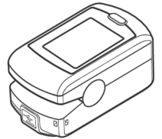
Tel: +86-335-8015430
Fax: +86-335-8015588
Technical support:+86-335-8015431
E-mail: cms@contecmed.com.cn
Website: http://www.contecmed.com
EC REPRESENTATIVE
Shanghai International Holding Corp. GmbH(Europe)
Address: Eiffestrasse 80, 20537, Hamburg, Germany
Tel: ＋49-40-2513175
Fax: ＋49-40-255726
E-mail: shholding@hotmail.com
CMS2.782.026(ZD)(TFT)(CE)ESS/1.0 1.4.01.01.612 2020.01

Instructions to User
Dear users, thank you very much for purchasing the Pulse Oximeter.
This Manual is written and compiled in accordance with the council directive MDD93/42/EEC for medical devices and harmonized standards. In case of modifications and software upgrades, the information contained in this document is subject to change without notice.
The Manual describes, in accordance with the Pulse Oximeter’s features and requirements, main structure, functions, specifications, correct methods for transportation, installation, usage, operation, repair, maintenance and storage, etc. as well as the safety procedures to protect both the user and equipment. Refer to the respective chapters for details.
Please read the User Manual carefully before using this product. The User Manual which describes the operating procedures should be followed strictly.Failure to follow the User Manual may cause measuring abnormality, equipment damage and human injury. The manufacturer is NOT responsible for the safety, reliability and performance issues and any monitoring abnormality, human injury and equipment damage due to users' negligence of the operation instructions. The manufacturer’s warranty service does not cover such faults.
Owing to the forthcoming renovation, the specific products you received may not be totally in accordance with the description of this User Manual. We would sincerely regret for that.
This product is medical device, which can be used repeatedly.
WARNING:
- Uncomfortable or painful feeling may appear if using the device ceaselessly, especially for the microcirculation barrier patients. It is recommended that the sensor should not be applied to the same finger for over 2 hours.
- For the special patients, there should be a more prudent inspecting in the placing process. The device can not be clipped on the edema and tender tissue.
- The light (the infrared is invisible) emitted from the device is harmful to the eyes, so the user and the maintenance man should not stare at the light.
- Testee can not use enamel or other makeup.
- Testee’s fingernail can not be too long.
- Please refer to the correlative literature about the clinical restrictions and caution.
- This device is not intended for treatment.
The User Manual is published by our company. All rights reserved.

1. Safety

1.1. Instructions for safe operations
- Check the main unit and all accessories periodically to make sure that there is no visible damage that may affect patient’s safety and monitoring performance about cables and transducers. It is recommended that the device should be inspected at least once a week. Please stop using the monitor if there is obvious damage to the device.
- Necessary maintenance must be performed by qualified service engineers ONLY. There are no user serviceable parts and users are not permitted to service the device by themselves.
- The oximeter cannot be used together with devices not specified in User’s Manual.Only the accessory that appointed or recommendatory by manufacture can be used with this device.
- This product is calibrated before leaving factory.

1.2. Warning
- Explosive hazard—DO NOT use the oximeter in environment with inflammable gas such as some ignitable anesthetic agents.
- DO NOT use the oximeter while the testee measured by MRI and CT.
- Be careful with the use of the lanyard cord. Improper use of the lanyard cord will cause device damage not covered under the manufacturer’s warranty. Swinging the device by the lanyard cord will void the warranty. Please do not use lanyard cord if allergic to lanyard cord.
- The disposal of scrap instrument and its accessories and packings(including battery, plastic bags, foams and paper boxes) should follow the local laws and regulations.Please check the packing before use to make sure the device and accessories are totally in accordance with the packing list, or else the device may have the possibility of working abnormally.
- Please choose the accessories which are approved or manufactured by the manufacturer, or else it may damage the device.
- Please choose the battery chargers which should be ensured compliance with the requirements of IEC 60601-1, or else it may damage the device.
- Please don't use the device in the course of charging.
- Please don't measure this device with functional tester for the device's related information.

1.3. Hazards
    - Keep the oximeter away from dust, vibration, corrosive substances, explosive materials, high temperature and moisture.
    - If the oximeter gets wet, please stop using it immediately.
    - When it is carried from cold environment to warm or humid environment, please do not use it immediately.
    - DO NOT operate keys on front panel with sharp materials.
    - High temperature or high pressure steam disinfection of the oximeter is not permitted. Refer to User Manual in the relative chapter (7.1)for instructions of cleaning and disinfection.
    - Do not immerse the oximeter in liquid. When it needs cleaning, please wipe its surface with disinfectant solution using a soft cloth. Do not spray any liquid directly onto the device.
    - When cleaning the device with water, the temperature should be lower than 60 ℃.
    - As to the fingers which are too thin or too cold, it would probably affect the normal measure of the patients' SpO₂ and pulse rate, please clip the thick finger such as thumb and middle finger deeply enough into the probe.
    - The update period of data is less than 5 seconds, which is changeable according to different individual pulse rate.
    - Please read the measured value when the waveform on screen is equably and steady-going, This measured value is optimal value. And the waveform at the moment is the standard one.
    - If some abnormal conditions appear on the screen during test process, pull out the finger and reinsert to restore normal use.
    - The device has normal useful life for three years since the first electrified use.
    - The hanging rope attached to the device is made from Non- allergy material, if particular group are sensitive to the hanging rope, stop using it. In addition, pay attention to the use of the hanging rope , do not wear it around the neck on the purpose of avoiding harm to the patient.
    - This device has the function of alarming, users can check on this function according to chapter 6.1 as a reference.
    - The device has the function of limits alarming, when the measured data is beyond the highest or lowest limit, the device would start alarming automatically on the premise of the alarming function is on.
    - The device has the function of alarming, this function can either be paused, or closed (default setting) for good.This function could be turned on through menu operation if you need.Please check the chapter 6.1 as a reference.
    - The device may not work for all patients. If you are unable to achieve stable readings, discontinue use.
    - A flexible circuit connects the two parts of the device. Do not twist or pull on the connection.
    - A flexible circuit connects the two parts of the device. Do not twist or pull on the connection.

1.4. FCC Rules(Bluetooth wired transmission)
This device complies with part 15 of the FCC Rules. Operation is subject to the following two conditions:
A. This device may not cause harmful interference;
B. This device must accept any interference received, including interference that may cause undesired operation.
Any changes or modifications not expressly approved by the party responsible for compliance could void the user's authority to operate the equipment.
Some electronic devices are susceptible to electromagnetic interference sent by this equipment if inadequately shielded. Please use this equipment at least 20 cm or as far as you can from TV set, radio and other automated office equipment so as to avoid interference.
This device is a radio transmitter and receiver. It is designed and manufactured not to exceed limits for exposure to radio frequency (RF) energy set by the Federal Communications Commission (FCC) of the U.S. Government. These limits are part of comprehensive guidelines and establish permitted levels of RF energy for the general population. The guidelines are based on standards that were developed by independent scientific organizations through periodic and thorough evaluation of scientific studies. The standards include a substantial safety margin designed to assure the safety of all persons, regardless of age or health.
This equipment has been tested and found to comply with the limits for a Class B digital device, pursuant to part 15 of the FCC Rules. These limits are designed to provide reasonable protection against harmful interference in a residential installation. This equipment generates, uses and can radiate radio frequency energy and, if not installed and used in accordance with the instructions, may cause harmful interference to radio communications. However, there is no guarantee that interference will not occur in a particular installation. If this equipment does cause harmful interference to radio or television reception, which can be determined by turning the equipment off and on, the user is encouraged to try to correct the interference by one or more of the following measures:
A. Reorient or relocate the receiving antenna.
B. Increase the separation between the equipment and receiver.
C. Connect the equipment into an outlet on a circuit different from that to which the receiver is connected.
D. Consult the dealer or an experienced radio/ TV technician for help.
A minimum separation distance of at least 0.2 m between this equipment and all persons shall be guaranteed to satisfy the RF exposure compliance.

2. Overview
The pulse oxygen saturation is the percentage of HbO₂ in the total Hb in the blood, so-called the O₂ concentration in the blood. It is an important bio-parameter for the respiration. A number of diseases relating to respiratory system may cause the decrease of SpO₂ in the blood, furthermore, some other causes such as the malfunction of human body's self-adjustment, damages during surgery, and the injuries caused by some medical checkup would also lead to the difficulty of oxygen supply in human body, and the corresponding symptoms would appear as a consequence, such as vertigo, impotence, vomit etc. Serious symptoms might bring danger to human's life. Therefore, prompt information of patients' SpO₂ is of great help for the doctor to discover the potential danger, and is of great importance in the clinical medical field. The Pulse Oximeter features in small volume, low power consumption, convenient operation and being portable.It is only necessary for patients to put one of his fingers into a probe for diagnosis, and a display screen will directly show the measured value of pulse oxygen saturation with the high veracity and repetition.

2.1. Features
A. Operation of the product is simple and convenient.
B. The product is small in volume, light in weight and convenient in carrying.
C. Low power consumption.

2.2. Major applications and scope of application
The Pulse Oximeter can be used in measuring the pulse oxygen saturation and pulse rate through finger. The product is suitable for being used in family, hospital, oxygen bar, community healthcare, physical care in sports (It can be used before or after doing sports, and it is not recommended to use the device during the process of having sport) and etc.
The problem of overrating would emerge when the patient is suffering from toxicosis which caused by carbon monoxide, the device is not recommended to be used under this circumstance.

2.3. Environment requirements
Storage Environment
a) Temperature : -40 ℃ ~ +60 ℃
b) Relative humidity : ≤95%
c) Atmospheric pressure : 500 hPa ~ 1060 hPa
Operating Environment
a) Temperature: 10 ℃ ~ 40 ℃
b) Relative Humidity : ≤75%.
c) Atmospheric pressure: 700 hPa ~ 1060 hPa

3. Principle
Principle of the Oximeter is as follows: An experience formula of data process is established taking use of Lambert Beer Law according to Spectrum Absorption Characteristics of Reductive Hemoglobin (Hb) and Oxyhemoglobin (HbO₂) in glow & near-infrared zones. Operation principle of the device is: Photoelectric Oxyhemoglobin Inspection Technology is adopted in accordance with Capacity Pulse Scanning & Recording Technology, so that two beams of different wavelength of lights can be focused onto human nail tip through perspective clamp finger-type sensor. Then measured signal can be obtained by a photosensitive element, information acquired through which will be shown on screen through treatment in electronic circuits and microprocessor.
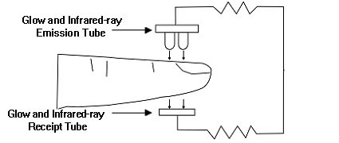
Figure 1

4. Technical specifications

4.1. Main performance
- Display of SpO₂ value, PR value, bar graph and pulse waveform.
- Low-battery indication: low-battery indication appears when the battery voltage is too low to work.Automatic standby function.
- Adjustable screen brightness, the display direction can be changed automatically.
- PR sound indication; sound prompt for over-limit, finger-out and low battery.
- Memory function.
- The data can be uploaded to the terminal equipment by wired mode.
- The data can be uploaded to the terminal equipment by wireless mode (Bluetooth wired equipment).
- Charging function.
- Time display.

4.2. Main parameters
A. Measurement of SpO₂
Measurement Range: 0% ~ 100%
Accuracy:70% ~ 100%, ±2%; 0% ~ 69%,unspecified
- Measurement of pulse rate
Measurement Range: 30 bpm ~ 250 bpm
Accuracy: ±2 bpm or ±2% (select larger)
- Resolution
SpO₂ : 1%, Pulse rate: 1 bpm.
- Measurement Performance in Weak Filling Condition:
SpO₂ and pulse rate can be shown correctly when pulse-filling ratio is 0.4%. SpO₂ error is
±4%, pulse rate error is ±2 bpm or ±2% (select larger).
- Resistance to surrounding light:
The deviation between the value measured in the condition of man-made light or indoor
natural light and that of dark room is less than ±1%.
- Power supply requirement: : DC 3.6 V - 4.2 V .
- Optical Sensor
Red light (wavelength is 660 nm, 6.65 mW)
Infrared (wavelength is 905 nm, 6.75 mW)
- Adjustable alarm range:
SpO₂ : 0% ~ 100%
Pulse Rate: 0 bpm ~ 254 bpm
- Bluetooth specifications(Bluetooth wired transmission)
Bluetooth protocol：Bluetooth Specification V4.0
USB protocol：USB V1.1、V2.0
Operating frequency：2.4 GHz ISM band
Modulation：GFSK(Gaussian Frequency Shift Keying)
Transmitting power：≤ 4 dBm, Class 2
Sensitivity：≤-84 dBm at 0.1% BER
Transfer rate：Asynchronous: 2.1 Mbps(Max) / 160 kbps Synchronous: 1 Mbps/1 Mbps
Safety features：Authentication and encryption
Support Services：Bluetooth SPP
J. FCC ID:2AB0GCMS50EW(Bluetooth wired transmission)

5. Installation

5.1. View of the front panel

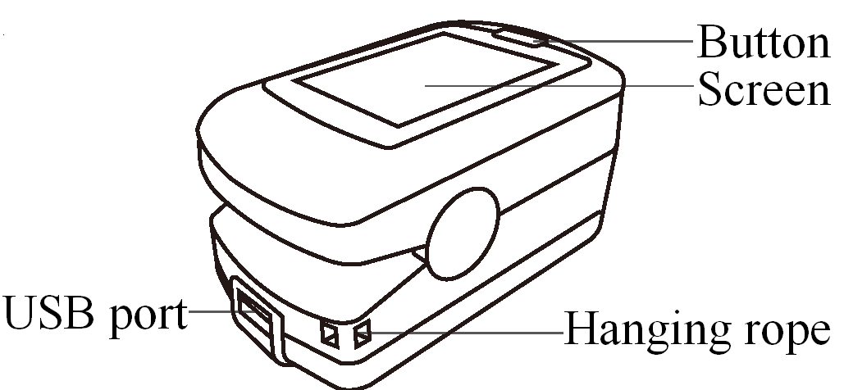

Figure 2 Appearance
USB interface: connect with USB cable
Button: exit standby, pause sound prompt, enter menu, menu operation.
RESET hole (see Figure 14): reset button inside of it, be used to reset the device.

5.2. Interface introduction
Bluetooth sign (Bluetooth wired equipment) . (see Figure 3).
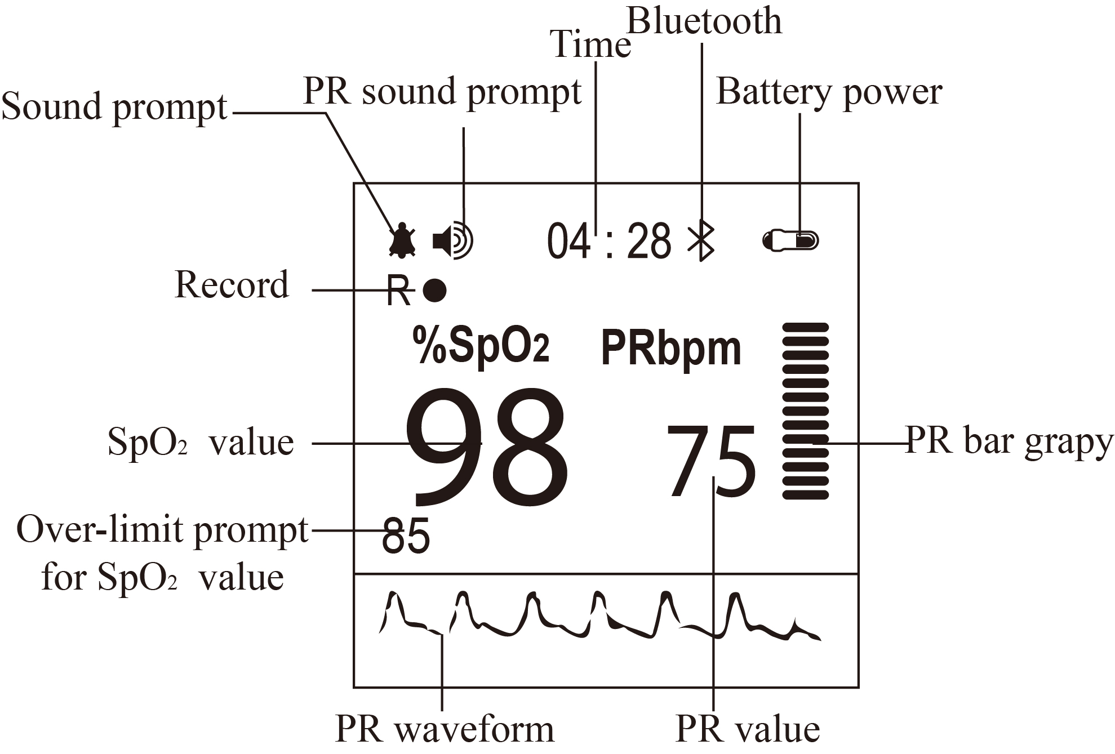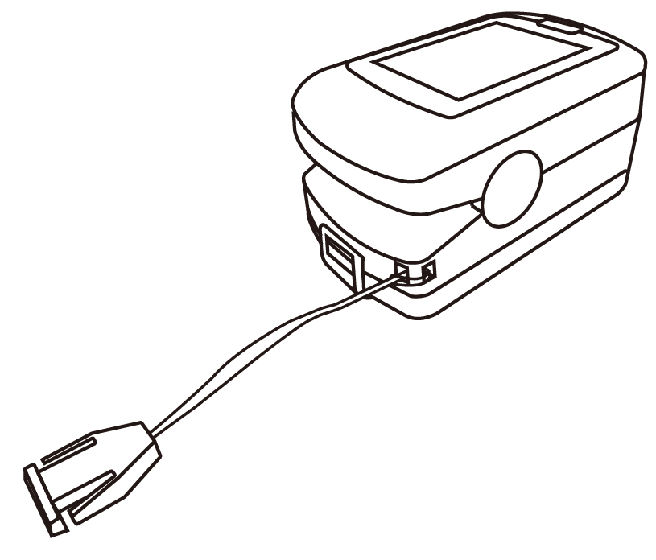
Figure 3 Measurement interface Figure 4 Sketch map for installing the hanging

5.3. Installing the hanging rope
A. Put the thinner side of the rope through the hole(see Figure 3 ).
B. Put the wider side of the rope through the thinner side which has been put through the hole, then tighten it.

5.4. USB port
USB port :It is used to connect a personal computer to export the trend data or charge the lithium battery via a data line(see Figure 3 ).

5.5. Structure and accessories
A. Structure: main unit, USB cable, power adapter (optional) and Bluetooth adapter (optional).
B. Accessories: one hanging, one power adapter (optional), one USB cable, one CD disk (including PC software, optional), one User Manual, Bluetooth adapter (optional).
Please check the device and accessories according to the list to avoid that the device can not work normally.

6. Operating guide

6.1. Application method

6.1. 1Measurement
- Pinch the clamp, put a finger into the rubber hole, then release it, as shown in Figure 5.
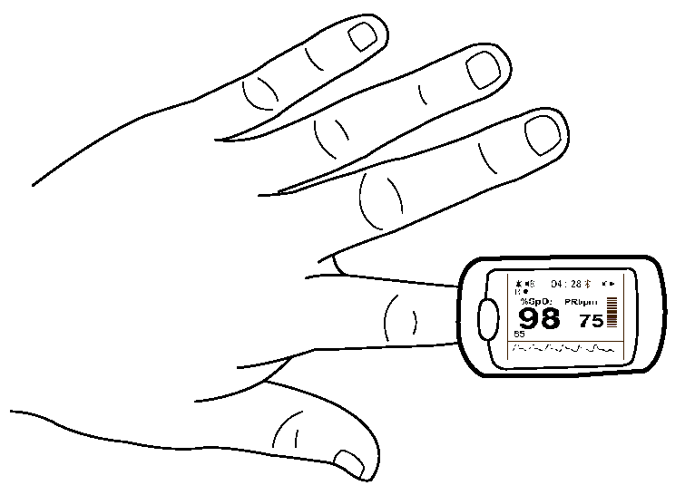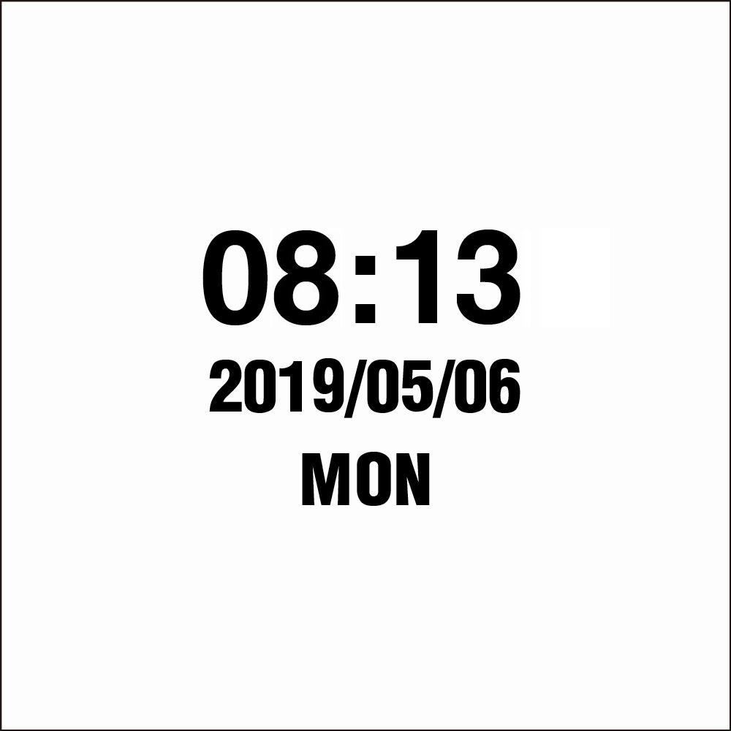
Figure 5 Sketch map for finger placement Figure 6 Time interface
When inserting the finger, the light emitting from the sensor must be directly irradiated to the side of the fingernail.
During measuring, do not shake the finger and keep quiet, not move.
B. Press “Button” to exit from the standby mode, then it displays the measurement interface.
Please synchronize the time with the master device when using it for the first time, refer to chapter 6.1.3 for relative operations.
C. Read the results directly from the screen after a period of time.
D. Under measurement interface and non-alarm state, short press the button to enter the clock interface (as Figure 6).
E. Under non-measurement state, it will enter standby mode automatically when there is no operation within 5s.

6.1.2 Pause sound prompt
A. Sound prompt, including: over-limit, low-battery and finger out.
B. Under the measurement interface, turn on the sound prompt, when the sound prompt occurs, short press the button to pause the sound prompt, and it will resume automatically after about 60s.
C. If you want to turn off the sound prompt permanently, please set it in menu.

6.1.3 Menu operation
Under the measurement interface, long press the button to enter the main menu interface as shown in Figure 7, sound, record, clock, Bluetooth, etc. can be set, methods are as followings:
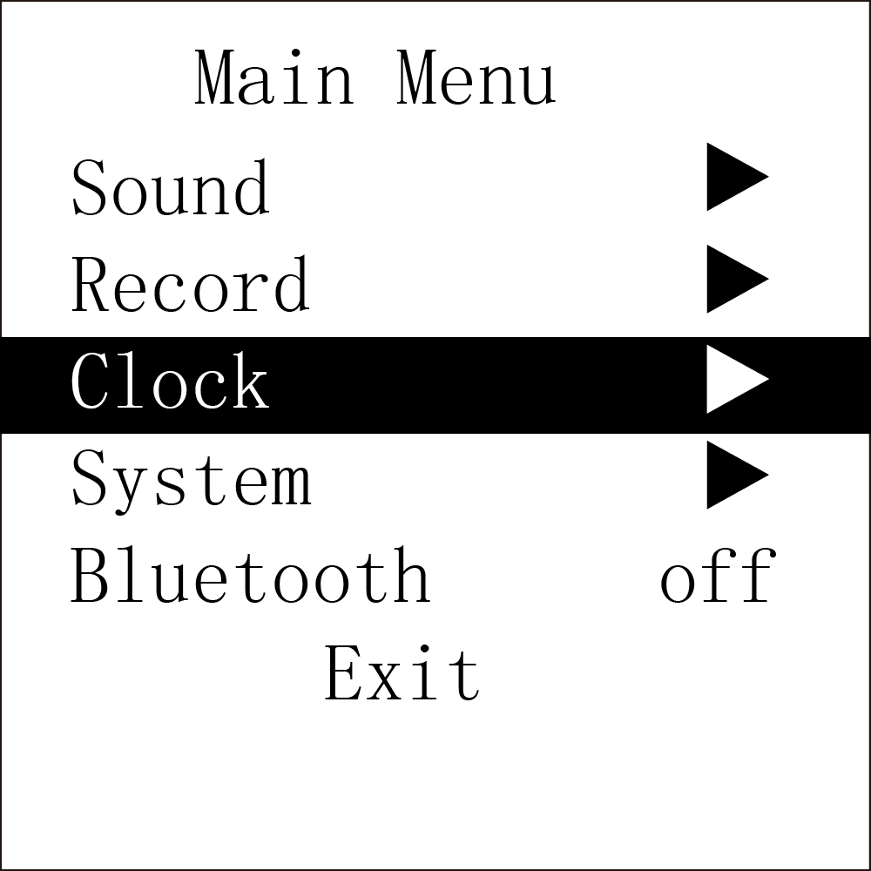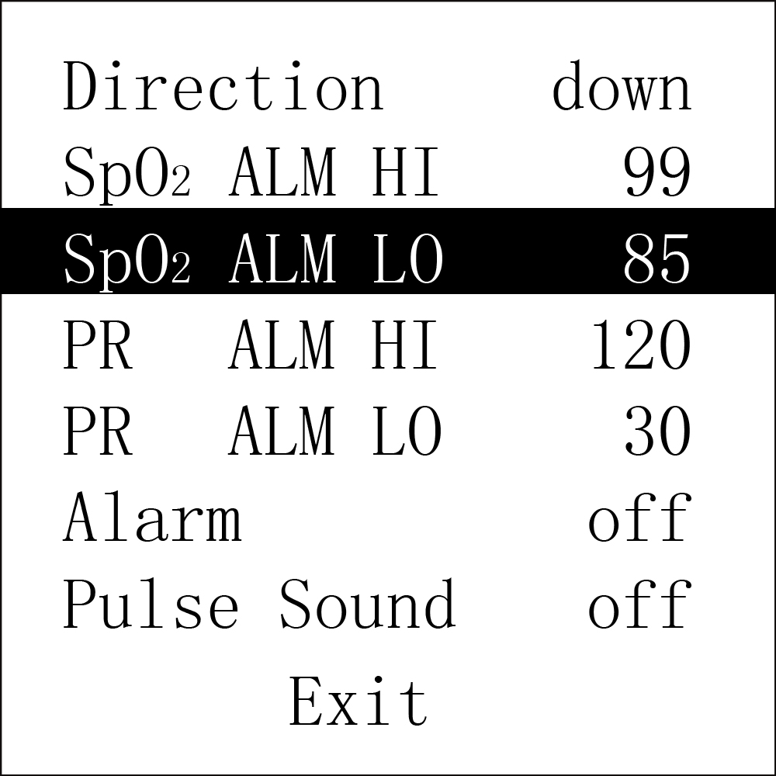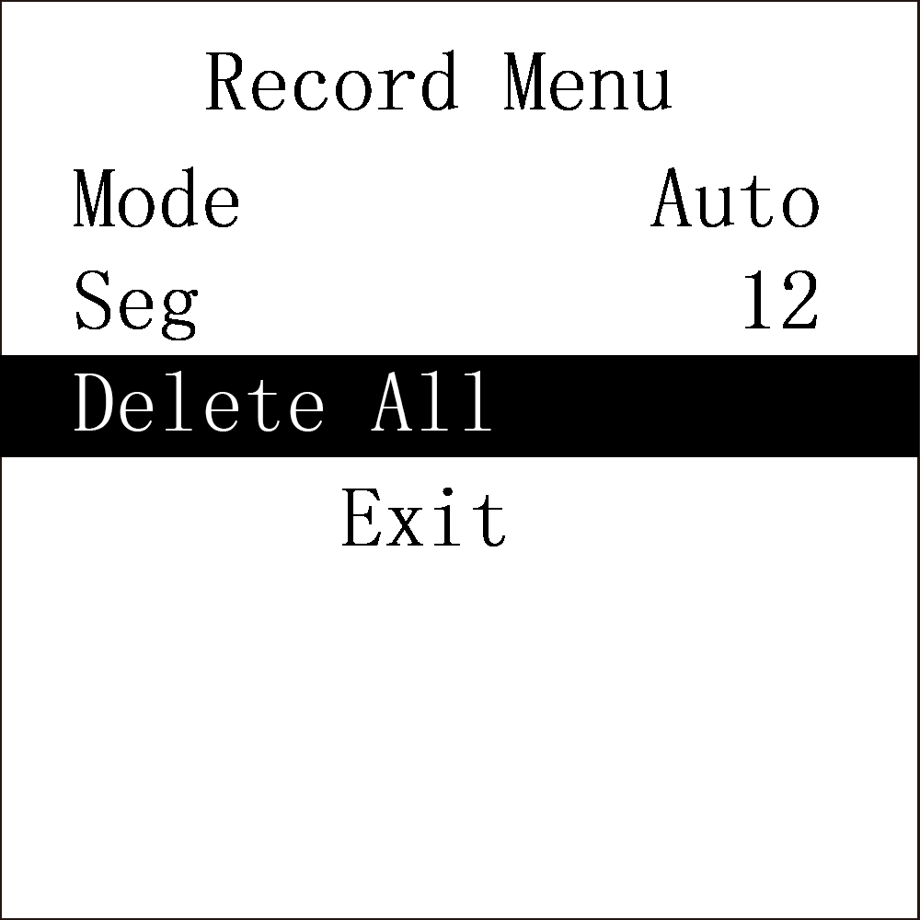
Figure 7 Main menu Figure 8 Setting interface for sound prompt Figure 9 Record menu

A. Sound prompt setting
Under main menu, short press the button to select “Sound”, then long press the button to enter its setting interface shown in Figure 8.
Short press the button to select the option to be adjusted, then long press the button to change the value.
“Direction”: direction, “up”: increase the value, “down”: decrease the value
“SpO₂ ALM HI”: upper limit prompt for SpO₂ over-limit
“SpO₂ ALM LO”: lower limit prompt for SpO₂ over-limit
“PR ALM HI”: upper limit prompt for PR over-limit
“PR ALM LO”: lower limit prompt for PR over-limit
“Alarm”: prompt for over-limit, “off”: close, “on”: open.
“Pulse Sound”: PR sound, “off”: close, “on”: open.
Lower limit can not exceed the upper limit, and the upper limit can not be lower than the lower limit when adjusting the values. SpO₂ range: 0 % ~ 100 %, PR range: 0 ~ 254 bpm
The values displayed in Figure 8 are the initial values of over-limit prompt.
After setting, short press the button to select “Exit”, then long press the button to exit sound setting interface, and return to “Main Menu” interface.

B. Data storage
Under the main menu, short press the button to select “Record”, then long press the button to enter the “Record Menu” interface as shown in Figure 9. It indicates that the device is storing when the red dot “R●” in measurement interface flickers.
Short press the button to select the option to be adjusted, then long press the button to change the value.
“Mode”: record mode selection, including: “Auto” and “Manual” mode. Under “Manual” mode, select to turn on / off memory by “Record”.
Auto record: start recording after stable data appear, pull out the finger to finish recording a group of data (99 group of data at most), the total duration does not exceed 72 hours.
Manual record: store up to 24-hour data.
When the memory is full, it will display “Memory is full!”, then it will enter the standby mode after several seconds. When exiting the standby mode next time, it will display “Memory is full!” to prompt user that the memory has been full, press the button again to enter the measurement interface.
under manual mode, when “Record” is “ON”, the device will prompt to clear the data stored last time.
It will display “Recording...” when there is no operation under record state for 30s, then it will enter energy saving mode after several seconds, long press the button to exit this mode; short press the button, it will display “Recording”.
Under data recording state, after the display screen turns off automatically, in order to save power, pulse sound indication will turn off automatically.
“Seg”: data segment.
After setting, short press the button to select “Exit”, long press the button to exit record menu and return to main menu.
“Delete All”: delete all records (auto record mode is shown as Figure 9).
Please upload data in time after recording, otherwise the data may be covered when the storage space is full.
The historical data will be deleted once switching the mode. Under record state, the record mode can not be switched; under manual mode, the record mode can be switched only when turning off recording firstly.

C. Time setting
a. Connect the master device to synchronize device time
After connecting real-time transmission (refer to relative chapter (6.1.4) for the connection method), select “Options”-“Synchronize Device Time” on PC software interface to synchronize the device time.
b. Set device time manually
Under main menu, short press the button to select “Clock”, long press the button to enter its sub-menu as shown in Figure 10.
Short press the button to select the option to be adjusted, then long press the button to change the value.
“Set Time”: set the time, “yes”: allow, “no”: prohibit
“Set Year”: set the year
“Set Month”: set the month
“Set Day”: set the day
“Set Hour”: set the hour
“Set Minute”: set the minute
Adjustable range for year: 2015 ~ 2045, month: 1 ~ 12, day: 1 ~ 30 (when there are 31 days in a month, it is 1 ~ 31), hour: 1 ~ 23, minute: 1 ~ 59.
After setting, short press the button to select “Exit”, then long press the button to exit time setting interface and return to main menu.
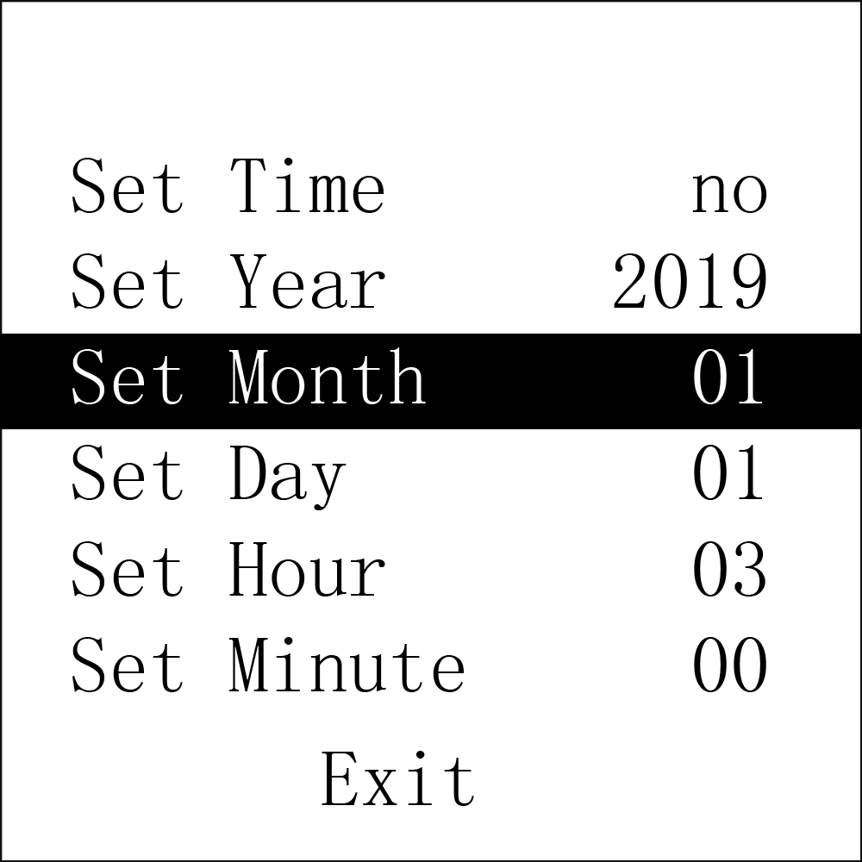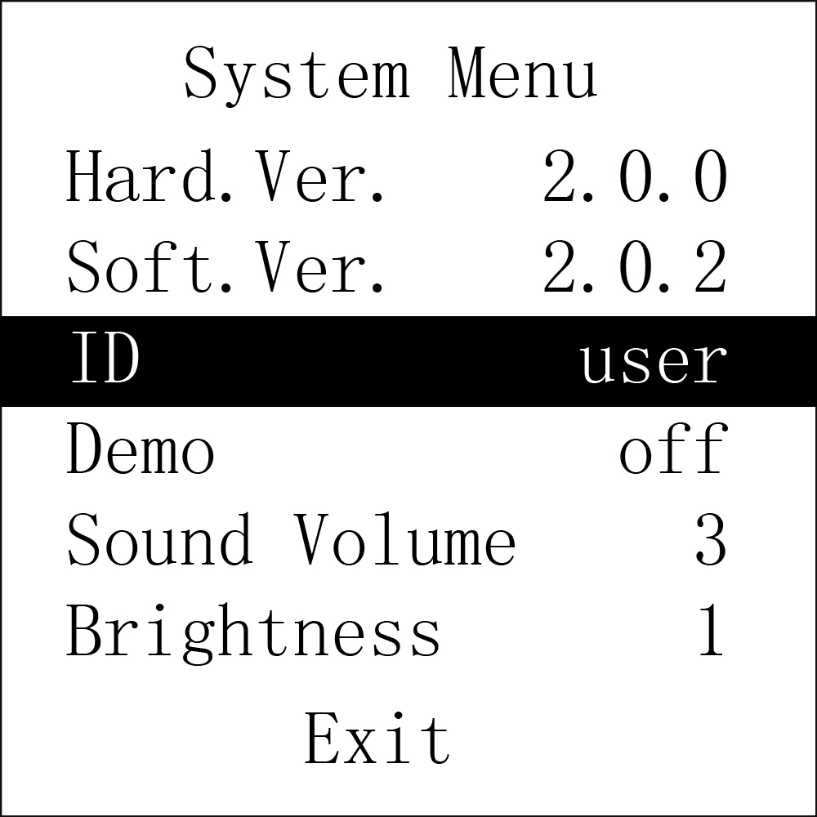
Figure 10 Main menu Figure 11 System menu

D. System setting and other options introduction
Under main menu, short press the button to select “System”, then long press the button to enter the interface as shown in Figure 11.
Short press the button to select the option to be adjusted, then long press the button to change the value.
“Hard.Ver.”: hardware version
“Soft.Ver.”: software version
“ID”: user name
“Demo”: set the Demo mode, “on”: turn on the Demo mode, “off”: turn off the Demo mode.
“Sound Volume”: set the sound volume, adjustable range: 1 ~ 3
“Brightness”: set the screen brightness, adjustable range: 1 ~ 4
After setting, short press the button to select “Exit”, then long press the button to exit the system menu and return to main menu.

E. Bluetooth setting (Bluetooth wired equipment)
Under main menu, short press the button to select “Bluetooth”, then long press the button to enter its selection interface as shown in Figure 12 and Figure 13. When the Bluetooth is “ON’,if no data is transmitted for some time, then the Bluetooth will be turned off automatically.

Under transmitting data by Bluetooth, the Bluetooth can not be turned off.
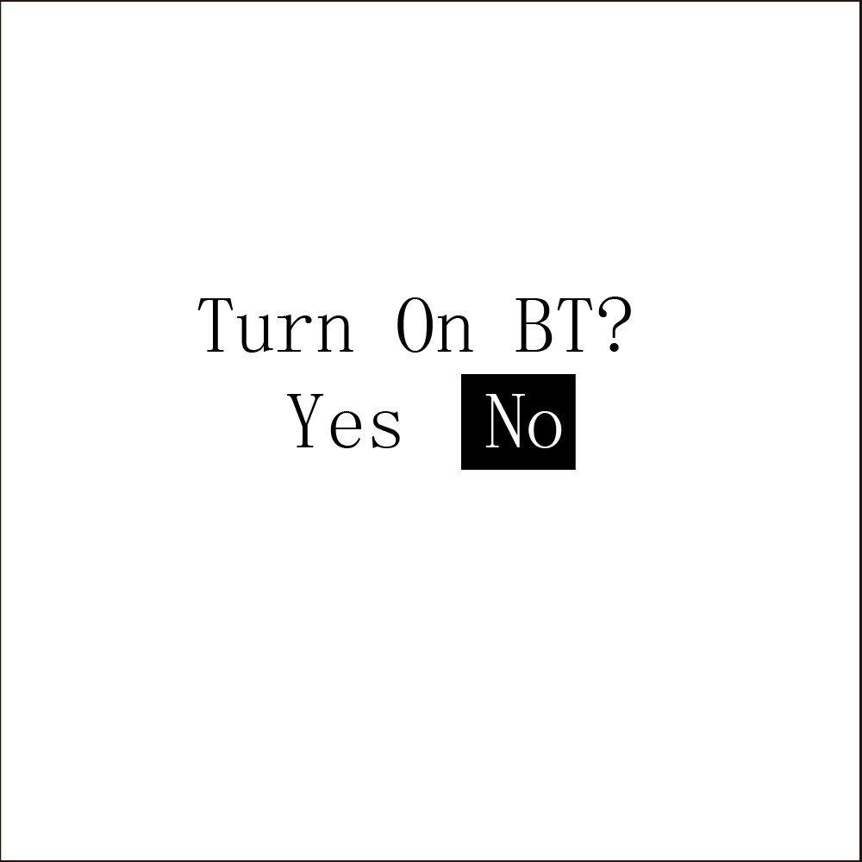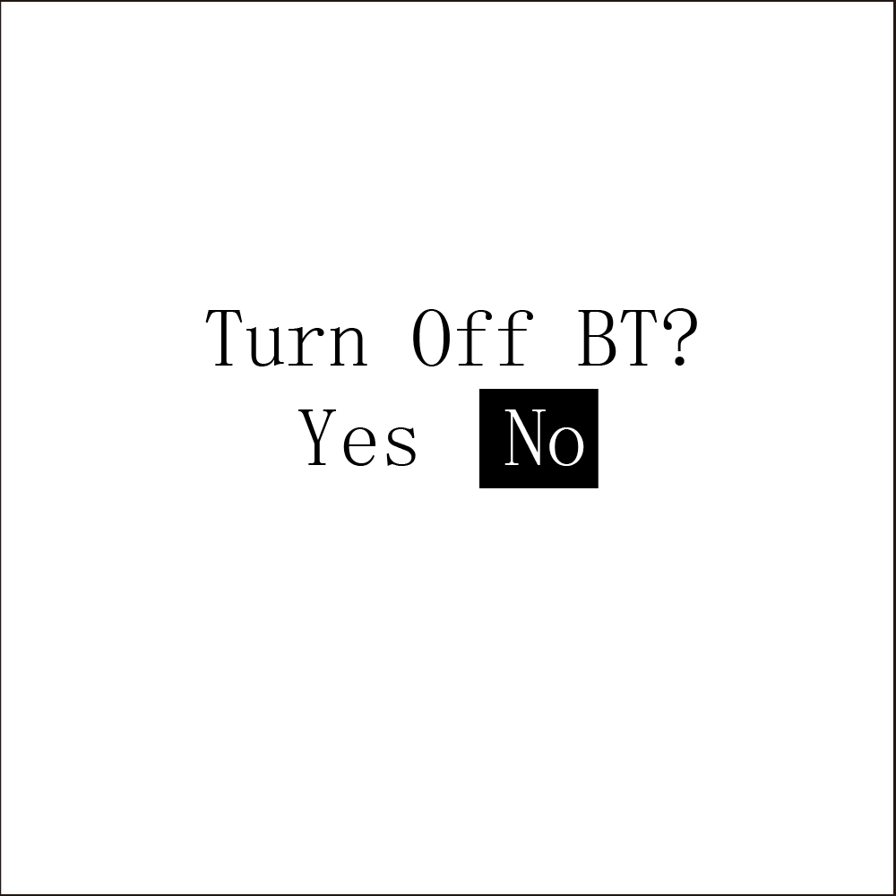
Figure 12 Bluetooth “ON” interface Figure 13 Bluetooth “OFF” interface

F. Exit main menu
Under main menu, short press the button to select “Exit”, then long press the button to exit the main menu and return to the measurement interface.

6.1.4 Data upload
A. Wired transmission
Connect the device to the computer by the USB cable,upload the data after connecting the PC software properly, refer to “Software operating instruction” for details.
The PC software can be downloaded from our official website.
B. Bluetooth transmission (Bluetooth wired transmission)
Turn on the device Bluetooth and the PC software to upload data, refer to “Software operating instruction” for details.

6.1.5 Charging
Power adapter can be selected to charge for the device. It indicates that the device is charging when the indicator is light, the charging is finished when the indicator is off.

6.1.6 Reset
Pinch the clip and the finger pad in accordance with Figure 14, then use a pointed and hard object (for example, a paper clip) to press the reset button inside of the reset hole, to reset the device.
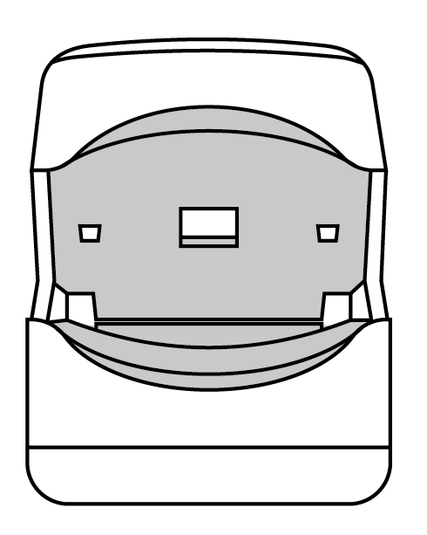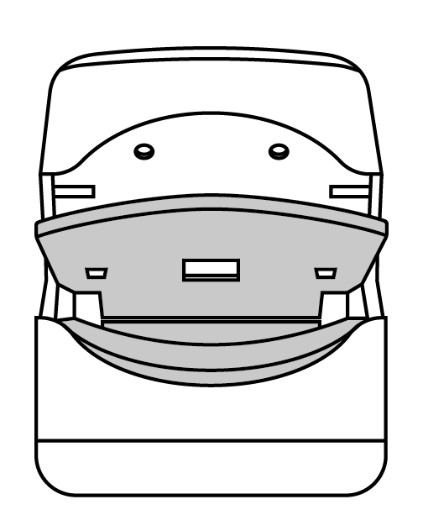
Reset hole
Figure 14 Sketch map for reset operation

6.2. Attention for operation
A. Please check the device before using, and confirm that it can work normally.
B. The finger should be in a proper position (see the attached illustration of Figure 5 for reference), or else it may result in inaccurate measure.
C. The SpO₂ sensor and photoelectric receiving tube should be arranged in a way with the
subject’ s arteriole in a position there between.
D. The SpO₂ sensor should not be used at a location or limb tied with arterial canal or blood pressure cuff or receiving intravenous injection.
E. Do not fix the SpO₂ sensor with adhesive or else it may result in venous pulsation and inaccurate measure of SpO₂ and pulse rate.
F. Excessive ambient light may affect the measuring result. It includes fluorescent lamp, dual ruby light, infrared heater, direct sunlight and etc.
G. Strenuous action of the subject or extreme electrosurgical interference may also affect the accuracy.
H. Testee can not use enamel or other makeup.
I. Please clean and disinfect the device after operating according to the User Manual (7.1).

6.3. Clinical restrictions
A. As the measure is taken on the basis of arteriole pulse, substantial pulsating blood flow of subject is required. For a subject with weak pulse due to shock, low ambient/body temperature, major bleeding, or use of vascular contracting drug, the SpO₂ waveform (PLETH) will decrease. In this case, the measurement will be more sensitive to interference.
B. For those with a substantial amount of staining dilution drug (such as methylene blue, indigo green and acid indigo blue), or carbon monoxide hemoglobin (COHb), or methionine (Me+Hb) or thiosalicylic hemoglobin, and some with icterus problem, the SpO₂ determination by this monitor may be inaccurate.
C. The drugs like dopamine, procaine, prilocaine, lidocaine and butacaine may also be a major factor blamed for serious error of SpO₂ measure.
D. As the SpO₂ value serves as a reference value for judgement of anemic anoxia and toxic anoxia, some patients with serious anemia may also report good SpO₂ measurement.

7. Maintain, transportation and storage

7.1. Cleaning and disinfecting
When using alcohol wipes to disinfect the device, please air dry or clean it with clean soft cloth.

7.2. Maintain
A. Please clean and disinfect the device before using according to the User Manual(7.1).
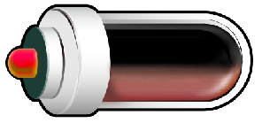
B. Please recharge the battery when the screen shows .
C. Recharge the battery soon after the over-discharge. The device should be recharged every six months when it is no regular used. It can extend the battery life following this guidance.
D. Users are advised to calibrate the device termly (or according to the calibrating program of hospital). It also can be performed at the state-appointed agent or just contact us for calibration.

7.3. Transportation and storage
A. The packed device can be transported by ordinary conveyance or according to transport contract. The device can not be transported mixed with toxic, harmful, corrosive material .
B. The best storage environment of the device is -40 ºC ~ 60 ºC ambient temperature and not higher than 95% relative humidity.

8. Troubleshooting

Trouble | Possible Reason | Solution
The SpO₂ and Pulse Rate can not be displayed normally | 1. The finger is not properly positioned.  2. The patient’s SpO₂ is too low to be detected. | 1. Place the finger properly and try again.  2. Try again; Go to a hospital for a diagnosis if you are sure the device works all right.
The SpO₂ and Pulse Rate are not displayed stably | 1. The finger is not placed inside deep enough.  2. The finger is shaking or the patient ismoving. | 1. Place the finger properly and try again.  2. Let the patient keep calm
The device can not be turned on | - The batteries are drained or almost drained.  2. The device’s malfunction | 1.Please recharge the battery  2. Please contact the local service center.
The display is off suddenly | - The product will enter standby mode when no signal is in the product within 5 seconds  - The battery is drained away or almost drained away . | 1.Normal  2.Please recharge the battery
The battery can not be full charged even after 10 hours charging time. | The battery is broken | Please contact the local service center.

Key of symbols

Signal | Description | Signal | Description
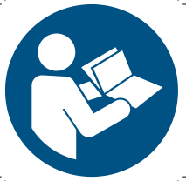 | Refer to instruction manual/booklet |  | 1. The finger clip falls off ( no finger inserted)]  2. Probe error  3. Signal inadequacy indicator
%SpO₂ | The pulse oxygen saturation(%) | IP22 | International Protection
bpm | Pulse rate (bpm) |  | WEEE (2002/96/EC)
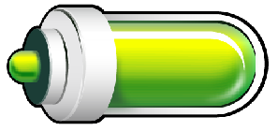 | Full-voltage |  | This item is compliant with Medical Device Directive 93/42/EEC of June 14, 1993, a directive of the European Economic Community.
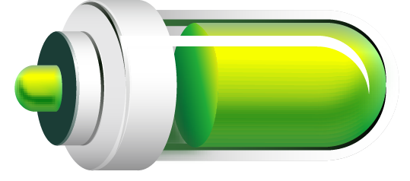 | Two grid of power | 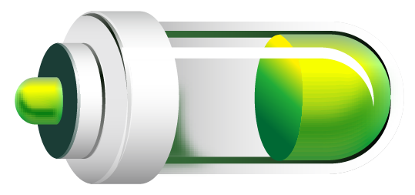 | One grid of power
 | Low-voltage |  | Manufacturer
 | Close the alarm sound indication |  | Date of manufacture
 | Pause the alarm sound indication | 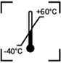 | Storage and Transport Temperature limitation
 | Open the alarm sound indication | 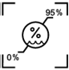 | Storage and Transport Humidity limitation
 | Close the pulse sound indication | 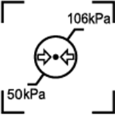 | Storage and Transport Atmospheric pressure limitation
 | Open the pulse sound indication |  | This side UP
 | Menu button/Exit standby mode |  | Fragile, handle with care
 | Type BF |  | Keep dry
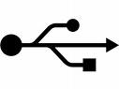 | USB |  | Recyclable
SN | Serial number |  | Bluetooth: ON  (Bluetooth wired equipment)
R●  Recording | Record state

Function specification

Information | Display Mode
The Pulse Oxygen Saturation(%SpO₂) | 2-digit digital LCD display
Pulse Rate(bpm) | 3-digit digital LCD display
Pulse Intensity (bar-graph) | Bar-graph LCD display
SpO₂ Parameter Specification
Measuring range | 0% ～ 100%, (the resolution is 1%).
Accuracy | 70% ～ 100%: ±2% ,Below 70% unspecified.
Average value | Calculate the Average value in every 4 measure value.  The deviation between average value and true value does not exceed 1%.
Pulse Parameter Specification
Measuring range | 30 bpm ～ 250 bpm, (the resolution is 1 bpm)
Accuracy | ±2 bpm or ±2% (select larger)
Average pulse rate | Moving calculate the Average pulse rate every 4  cardio-beat,s cycle.  The deviation between average value and true value does not exceed 1%
Safety Type | Interior Battery,BF Type
Pulse Intensity
Range | Continuous bar-graph display, the higher display indicate the stronger pulse.
Battery Requirement
Voltage 3.7 rechargeable lithium battery × 1
Battery working life
Charge and discharge no less than 500 times.
Power Adapter
Input Voltage | 100 to 240 VAC, 50/60 Hz
Output voltage | 5 V DC
Output current | 1000 mA
Oximeter Probe
Wavelength:660nm 905nm
Dimensions and Weight
Dimensions | 57(L) × 32(W) × 30 (H) mm
Weight | About 50 g (with the lithium battery*1)

Appendix 1

State | Alarm condition delay | Alarm signal generation delay
Low voltage alarm | 60 s | 5 ms
SpO₂ alarm | 1 s | 5 ms
Pulse rate alarm | 1 s | 5 ms
Probe error alarm | 16 ms | 5 ms

Appendix 2
Guidance and manufacture's declaration
Guidance and manufacture’s declaration – electromagnetic emissions-
for all EQUIPMENT and SYSTEMS
Guidance and manufacture’s declaration – electromagnetic emission
The CMS50E Pulse Oximeter is intended for use in the electromagnetic environment specified below. The customer of the user of the CMS50E Pulse Oximeter should assure that it is used in such and environment.
Emission test | Compliance | Electromagnetic environment – guidance
RF emissions  CISPR 11 | Group 1 | The CMS50E Pulse Oximeter uses RF energy only for its internal function. Therefore, its RF emissions are very low and are not likely to cause any interference in nearby electronic equipment.
RF emission  CISPR 11 | Class B | The CMS50E Pulse Oximeter is suitable for use in all establishments, including domestic establishments and those directly connected to the public low-voltage power supply network that supplies buildings used for domestic purposes.
Guidance and manufacture’s declaration – electromagnetic immunity –
for all EQUIPMENT and SYSTEMS
Guidance and manufacture’s declaration – electromagnetic immunity
The CMS50E Pulse Oximeter is intended for use in the electromagnetic environment specified below. The customer or the user of CMS50E Pulse Oximeter should assure that it is used in such an environment.
Immunity test |  | IEC 60601 test level |  | Compliance level |  | Electromagnetic environment - guidance
Electrostatic discharge (ESD)  IEC 61000-4-2 |  | 8 kV contact  15 kV air |  | 8 kV contact  15 kV air |  | Floors should be wood, concrete or ceramic tile. If floor are covered with synthetic material, the relative humidity should be at least 30%. the manufacturer may recommend the ESD precautionary procedures to user.
Power frequency (50Hz) magnetic field  IEC 61000-4-8 | 30A/m |  | 30A/m |  | Power frequency magnetic fields should be at levels characteristic of a typical location in a typical commercial or hospital environment.

Guidance and manufacture’s declaration – electromagnetic immunity –
for EQUIPMENT and SYSTEMS that are not LIFE-SUPPORTING
Guidance and manufacture’s declaration – electromagnetic immunity
The CMS50E Pulse Oximeter is intended for use in the electromagnetic environment specified below. The customer or the user of CMS50E Pulse Oximeter should assure that it is used in such an environment.
Immunity test | IEC 60601 test level | Compliance level | Electromagnetic environment - guidance
Conducted RF  IEC 61000-4-6  Radiated RF  IEC 61000-4-3 | 3V(0.15MHz–80MHz),6V(in ISM bands between 0.15MHz and 80MHz)  10 V/m  80 MHz to 2.7GH | 3V(0.15MHz–80MHz),6V(in ISM bands between 0.15MHz and 80MHz)  10 V/m | Portable and mobile RF communications equipment should be used no closer to any part of the CMS50E, including cables, than the recommended separation distance calculated from the equation applicable to the frequency of the transmitter.  Recommended separation distance  $d=\left[\frac{3\text{.}5}{V_{1}}\right]\sqrt{P}$  $d=\left[\frac{3\text{.}5}{E_{1}}\right]\sqrt{P}$80 MHz to 800 MHz  $d=\left[\frac{7}{E_{1}}\right]\sqrt{P}$ 800 MHz to 2.7 GHz  Where P is the maximum output power rating of the transmitter in watts (W) according to the transmitter manufacturer and d is the recommended separation distance in metres (m).  Field strengths from fixed RF transmitters, as determined by an electromagnetic site survey,a should be less than the compliance level in each frequency range.b  Interference may occur in the vicinity of equipment marked with the following symbol:  
NOTE 1 At 80 MHz and 800 MHz, the higher frequency range applies.
NOTE 2 These guidelines may not apply in all situations. Electromagnetic propagation is affected by absorption and reflection from structures, objects and people.
a Field strengths from fixed transmitters, such as base stations for radio (cellular/cordless) telephones and land mobile radios, amateur radio, AM and FM radio broadcast and TV broadcast cannot be predicted theoretically with accuracy. To assess the electromagnetic environment due to fixed RF transmitters, an electromagnetic site survey should be considered. If the measured field strength in the location in which the CMS50E is used exceeds the applicable RF compliance level above, the CMS50E should be observed to verify normal operation. If abnormal performance is observed, additional measures may be necessary, such as reorienting or relocating the CMS50E.
b Over the frequency range 150 kHz to 80 MHz, field strengths should be less than 3 V/m.
Recommended separation distances between portable and mobile
RF communications equipment and the EQUIPMENT or SYSTEM –
for EQUIPMENT or SYSTEM that are not LIFE-SUPPORTING
Recommended separation distances between
portable and mobile RF communications equipment and the CMS50E Pulse Oximeter.
The CMS50E Pulse Oximeter is intended for use in an electromagnetic environment in which radiated RF disturbances are controlled. The customer or the user of the CMS50E Pulse Oximeter can help prevent electromagnetic interference by maintaining a minimum distance between portable and mobile RF communications equipment (transmitters) and the CMS50E Pulse Oximeter as recommended below, according to the maximum output power of the communications equipment.
Rated maximum output power of transmitter  (W) | Separation distance according to frequency of transmitter(m)
Rated maximum output power of transmitter  (W) | 150 kHz to 80 MHz  $$d=\left[\frac{3\text{.}5}{V_{1}}\right]\sqrt{P}$$ | 80 MHz to 800 MHz  $$d=\left[\frac{3\text{.}5}{E_{1}}\right]\sqrt{P}$$ | 800 MHz to 2.7 GHz  $$d=\left[\frac{7}{E_{1}}\right]\sqrt{P}$$
0.01 | 0.058 | 0.035 | 0.07
0.1 | 0.18 | 0.11 | 0.22
1 | 0.58 | 0.35 | 0.7
10 | 1.83 | 1.10 | 2.21
100 | 5.8 | 3.5 | 7
For transmitters rated at a maximum output power not listed above, the recommended separation distance d in metres (m) can be estimated using the equation applicable to the frequency of the transmitter, where P is the maximum output power rating of the transmitter in watts (W) according to the transmitter manufacturer.
NOTE 1 At 80 MHz and 800 MHz, the separation distance for the higher frequency range applies.
NOTE 2 These guidelines may not apply in all situations. Electromagnetic propagation is affected by absorption and reflection from structures, objects and people.

